**Data Loading – HDFS, Hive**

**1) Load crimes data directly (as crimes.csv) from the city of chicago data portal and store in HDFS**

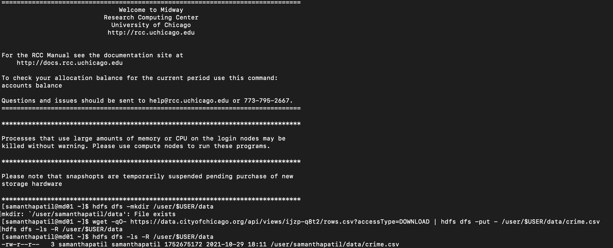

**2) Create an external Hive table from this data set called chicago_crimes in a database with name as <your userid> on RCC. (Try to match the column names from the metadata link above. Ensure that column names have no spaces or special characters)**

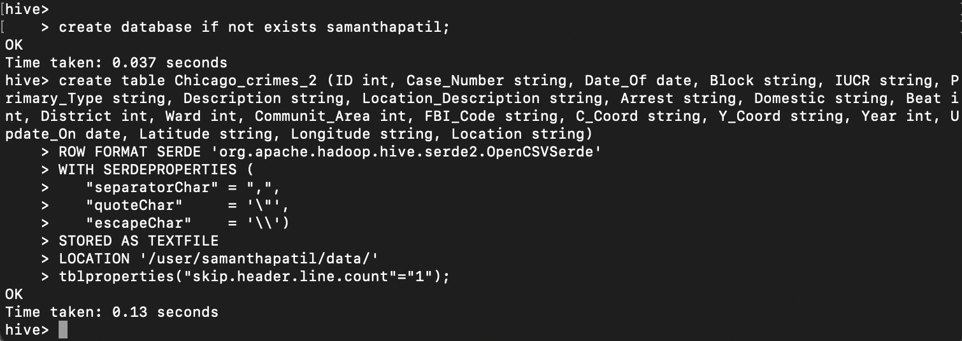

**3) Load data from crimes csv into chicago_crimes Hive table.**

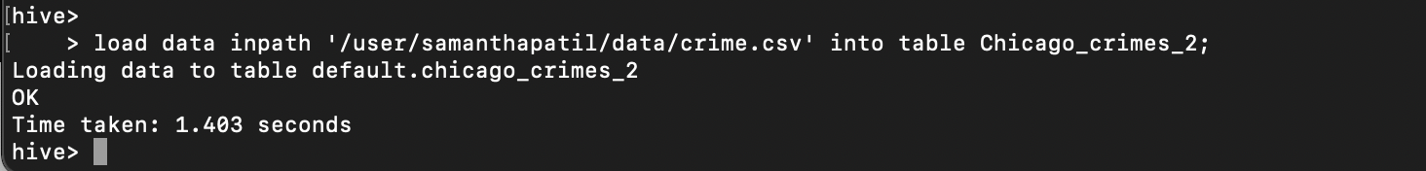

**Data Manipulation - Hive**

**4) What are earliest and most recent dates of the crimes recorded in the dataset and what are the types of those crimes. (Dates might vary based on when you download the dataset)**

**select Date_Of,Primary_Type from chicago_crimes order by Date_Of asc nulls last limit 5;**

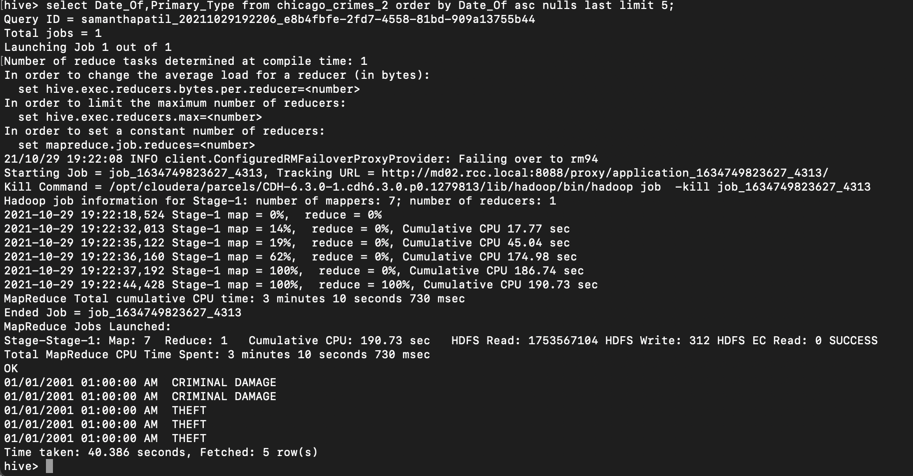

**5) List the top 5 and bottom 5 primary crime types based on total count of occurrences**

**select Primary_Type, count(*) as cnt from chicago_crimes group by Primary_Type order by cnt;**

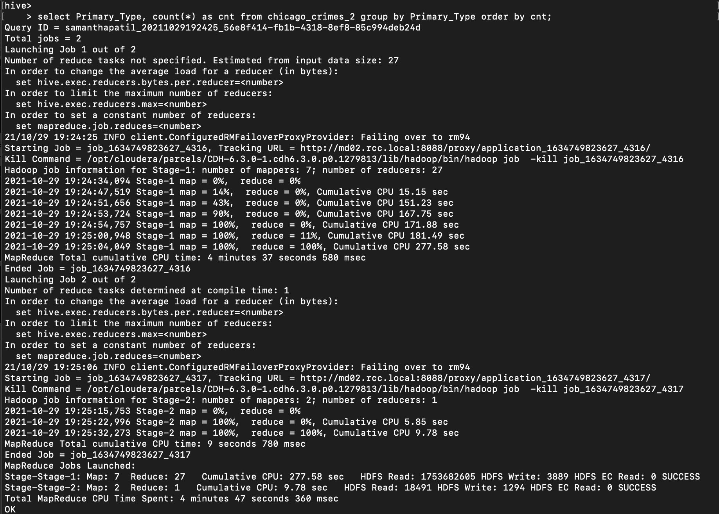

**Top 5 primary crime types**

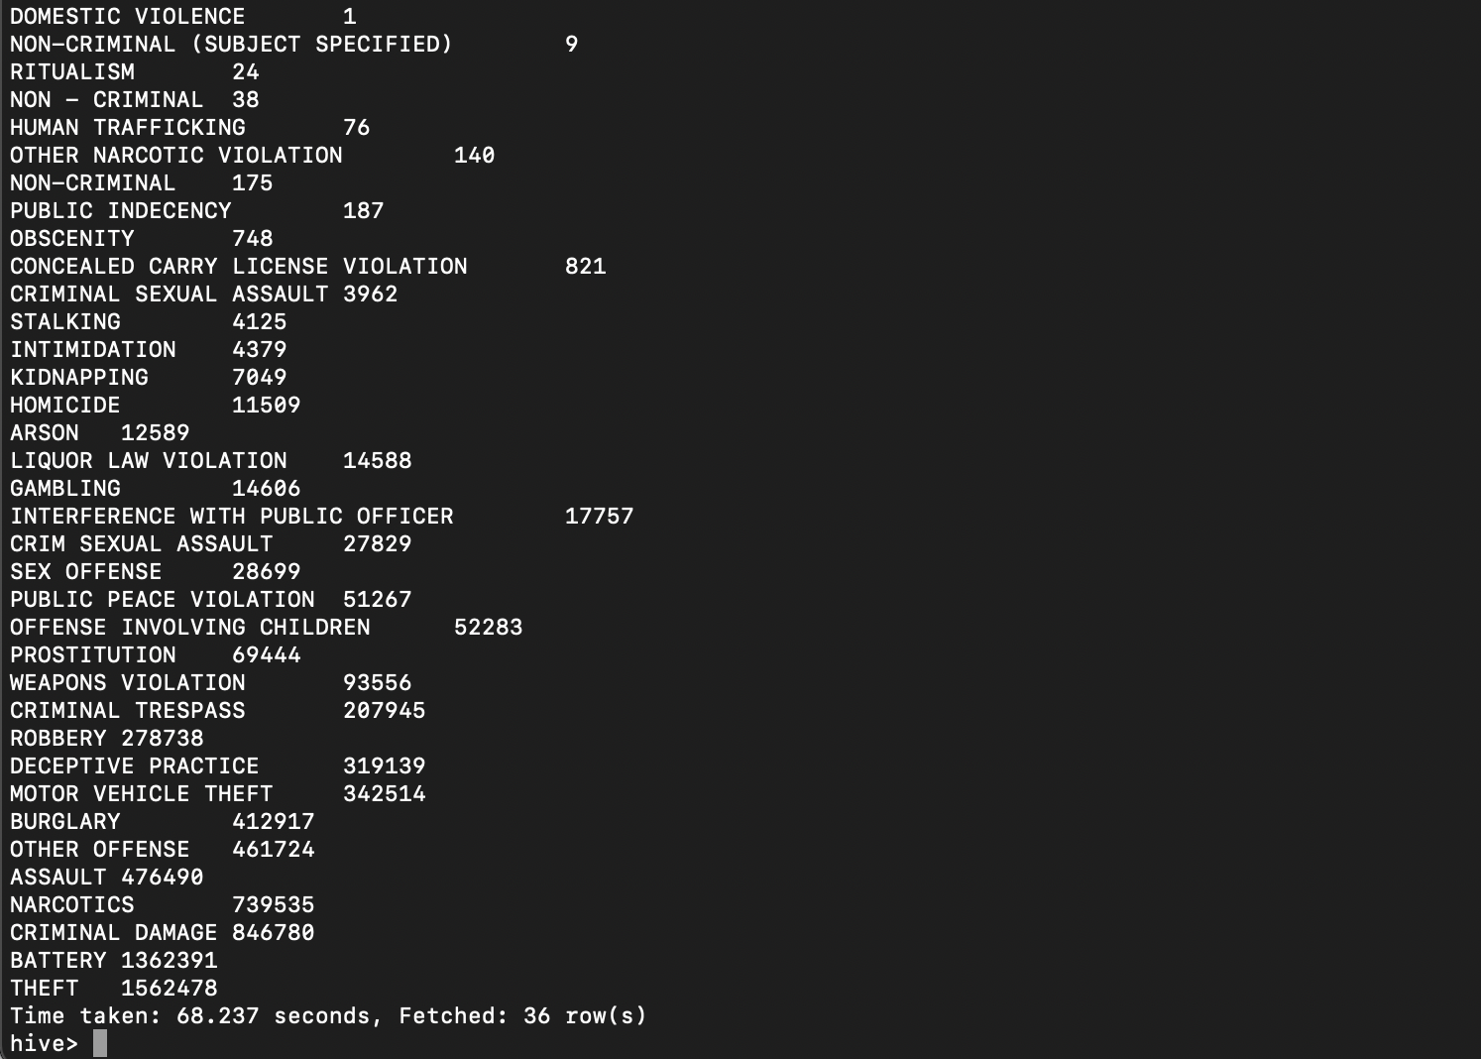

**Bottom 5 primary crime types**



**6) Which location description has the highest number of homicides associated with it ?**

**select Location_Description, count(*) as cnt from chicago_crimes where Primary_Type = ‘HOMICIDE’ group by Location_Description order by cnt;**

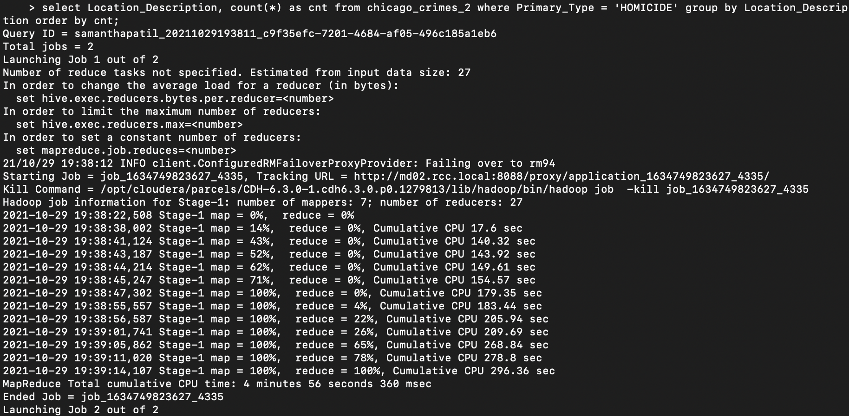

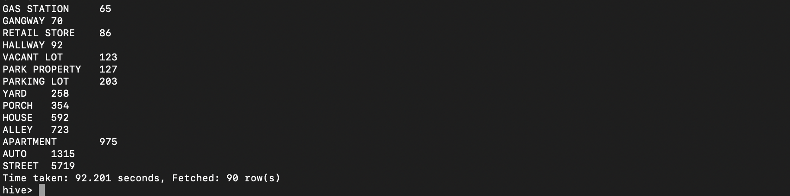

**7) Which are the most dangerous and least dangerous police districts in the Chicago area?**

select District, count(*) as cnt from chicago_crimes_2 where Primary_Type in (HUMAN TRAFFICKING, CRIMINAL SEXUAL ASSAULT,STALKING, INTIMIDATION, KIDNAPPING, HOMICIDE, ARSON, CRIM SEXUAL ASSAULT, SEX OFFENSE, OFFENSE INVOLVING CHILDREN, CRIMINAL TRESPASS, ROBBERY, DECEPTIVE PRACTICE, MOTOR VEHICLE THEFT, BURGLARY, ASSAULT, CRIMINAL DAMAGE, BATTERY) group by District order by cnt;

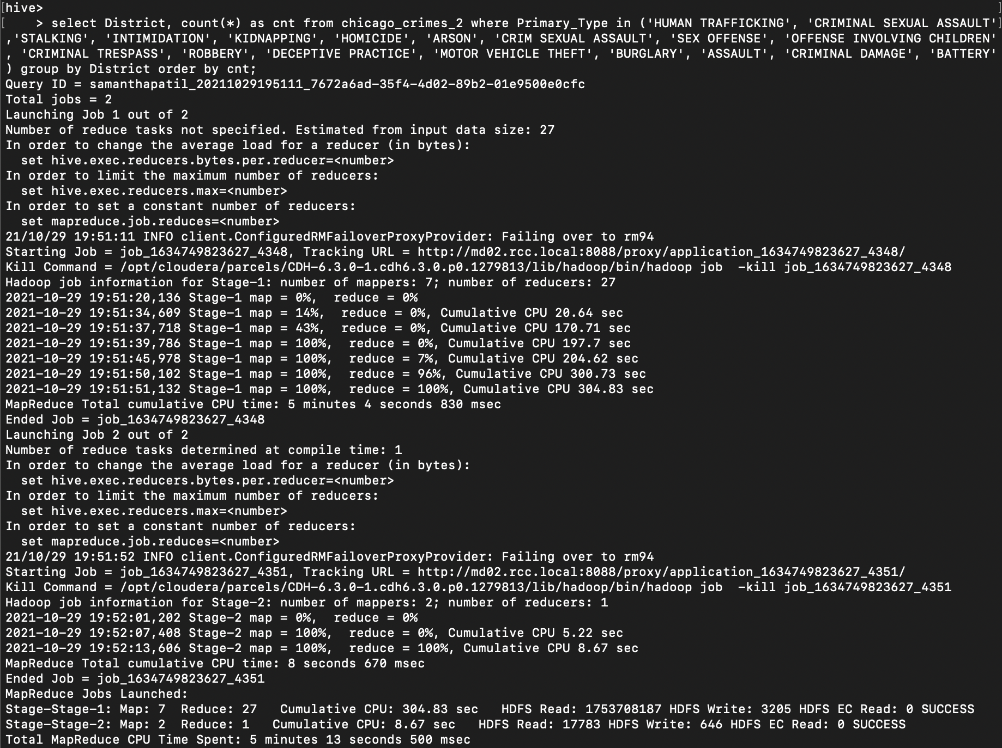

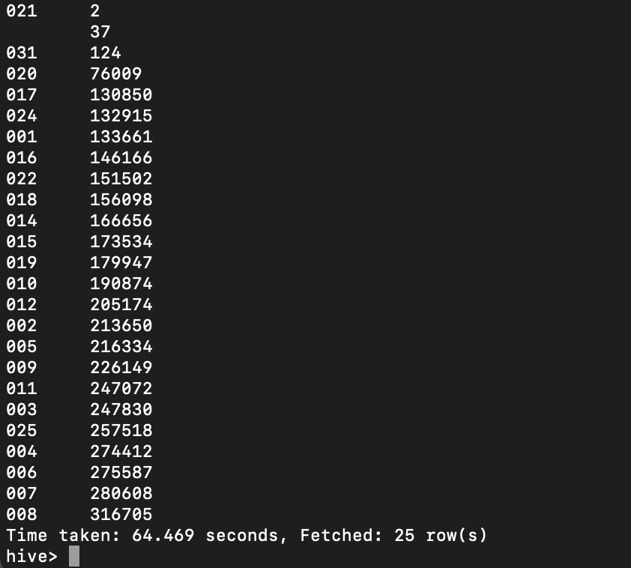

**8) What is the average number assaults per month that occurred in 2019. Has that number increased since the prior period ?**

SELECT Year, AVG (a.count) AS avg FROM ( SELECT Year, count(*) AS count, MONTH(date_of) FROM chicago_crimes_2 WHERE Primary_Type in ('CRIMINAL SEXUAL ASSAULT', 'CRIM SEXUAL ASSAULT','ASSAULT') GROUP BY Year, MONTH(date_of)) AS a group by Year;

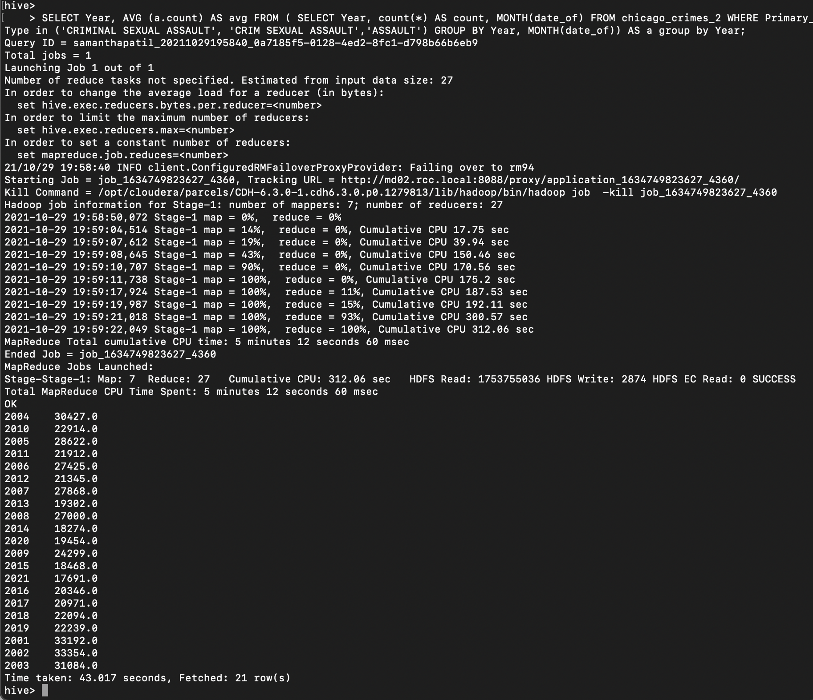

**9) From chicago_crimes table create a smaller (summarized) external table in Hive (that supports questions 9 and 10) and download this summarized table to your computer as a CSV file.**

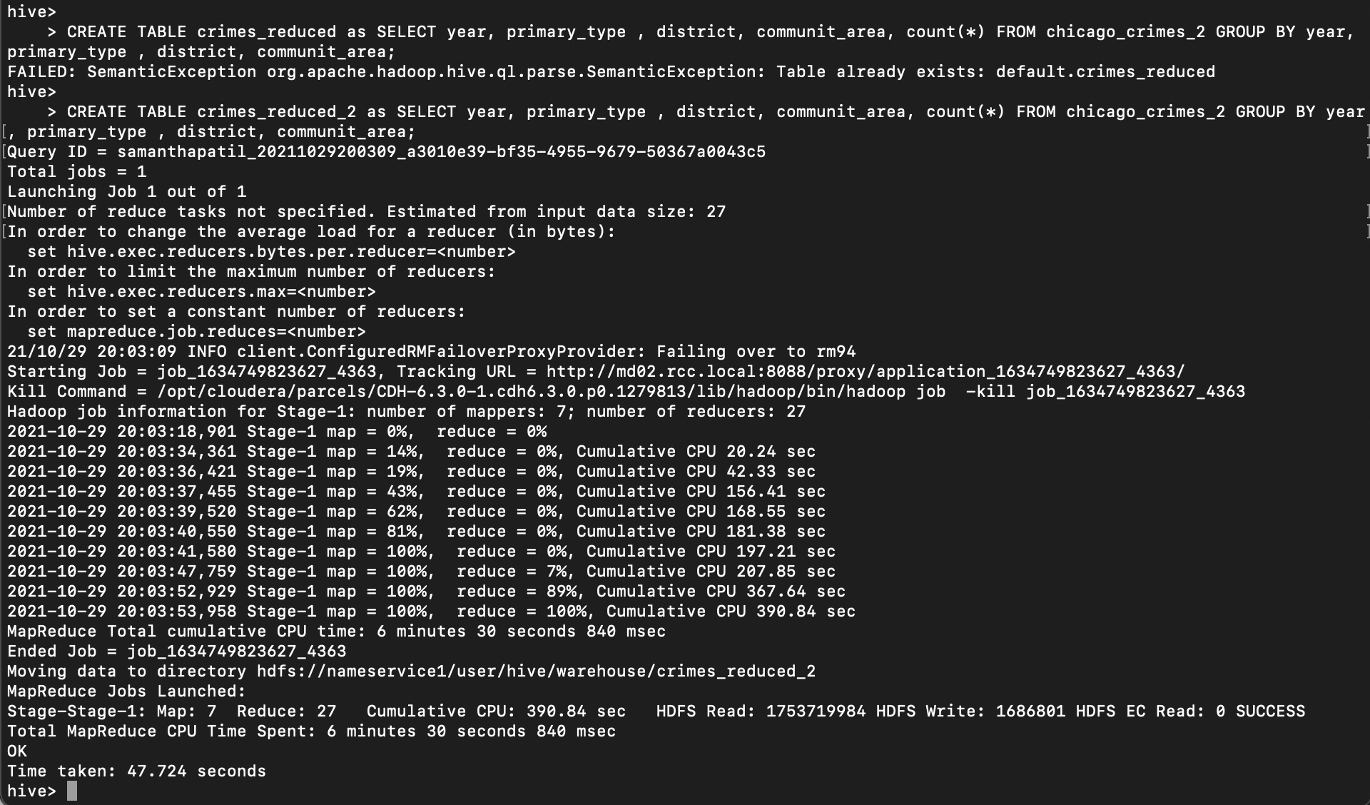

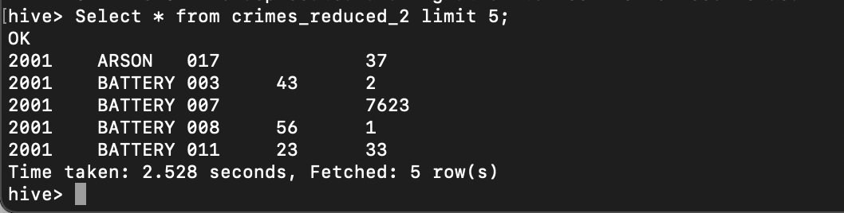

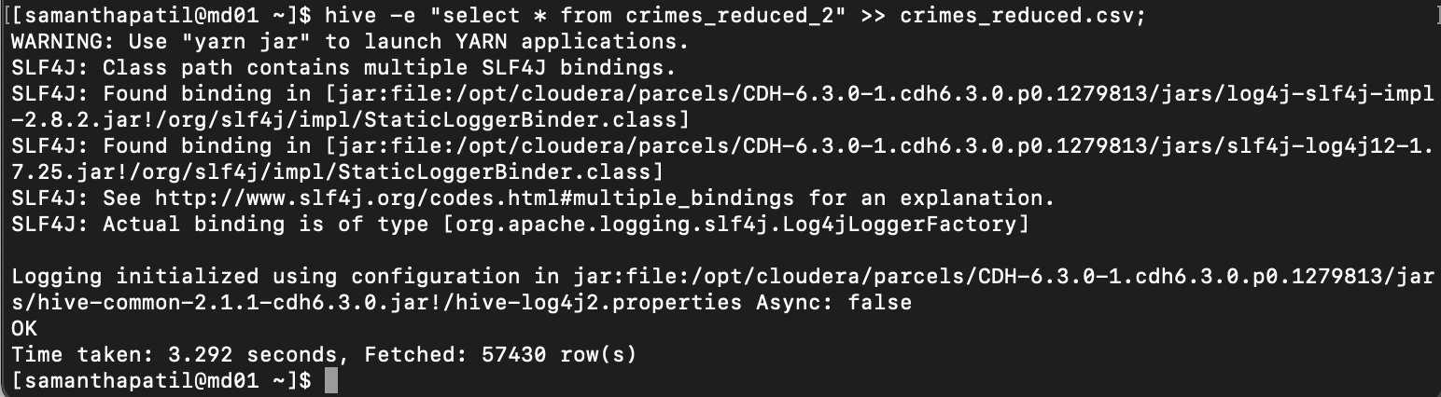

**Python Visualization in HTML - Q 10 & 11 are in separate Python-html file.**